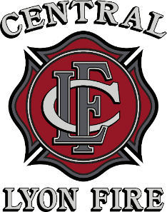

Tim McHargue
Fire Chief

DRAFT
February 12, 2026

Nevada Department of Taxation
Local Government & Finance
Ms. Lana Rady
3850 Arrowhead Drive, 2nd Floor
Carson City, NV 89706

Dear Ms. Rady,

On February 12, 2026 at the Central Lyon County Fire Protection District Board of Directors meeting, the Board voted unanimously to authorize the District tax at the maximum allowable rate for fiscal year 2026-2027 to keep pace with increasing demands for service. In the event revenue projections are greater than anticipated, the Board may choose to maintain or only partially raise our current tax rate during the budget process.

If you have any questions, or need any additional information, please contact me at (775) 246-6209.

Sincerely,

Amber Law
Business Manager / HR Director
alaw@centralfirenv.org

